Credit goes to Udacity student: Ahmed

**Setup Route-Planning-Project on Windows**

1- Install visual studio from this link <https://visualstudio.microsoft.com/downloads/>

2- Install Cmake from this link<https://cmake.org/download/>

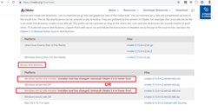

3- install Git bash from this link

<https://git-scm.com/downloads>

4- Install Vcpkg by flowing the procedures in this link

<https://github.com/Microsoft/vcpkg>

5- Open a powershell window and navigate to the vcpkg repository.

You can easily do that by navigate to vcpkg directory in you PC and right_clickthis choose Git Bash Here

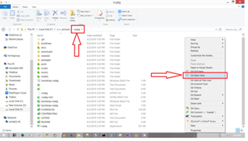

6- Install cairo for win32 with the command ".\vcpkg.exe install cairo"

7- Install cairo for x64 with the command ".\vcpkg.exe install cairo --triplet x64-windows"

8- Install graphicsmagick for win32 with the command ".\vcpkg.exe install graphicsmagick"

9- Install graphicsmagick for x64 with the command ".\vcpkg.exe install graphicsmagick --triplet x64-windows"

10- Inspect which packages have been installed with the command ".\vcpkg.exe list" Both Win32 and x64 builds are supported and being tested.

11- Navigate to Sample folder you will find it in this directory .....\P0267_RefImpl\P0267_RefImpl\Samples

11-Delete all folders there as we don't need them, You can leave them but they will make your project bigger

12- Make sure that you did NOT deleted CMakeLists File

13- Navigate Git Bash to Sample directory and Download the repository of our project using this command line

git clone https://github.com/udacity/CppND-Route-Planning-Project.git --recurse-submodules

**NOW we need to edit some Cmake files in order to compile our project**

14- Open the CMakeLists file in the ...\P0267_RefImpl directory and comment line (44 and 45). as these two lines will produce error as they conflict with some lines in our project

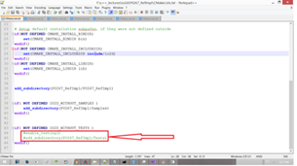

15- Open the CMakeLists file in the ....\P0267_RefImpl\P0267_RefImpl\Samples\CppND-Route-Planning-Project\srcdirectory and comment line 16,17,18 and 19. and past these lines under the commented lines target_link_libraries(${PROJECT_ID} io2d pugixml )

**Now your project is ready to be compiled by Cmake**

16- Open the CmakeLists file in this directory ......\P0267_RefImpl\P0267_RefImpl\Samples\CppND-Route-Planning-Projectand comment this line find_package(io2d REQUIRED) Like in the image below and comment this line

>>find_package(io2d REQUIRED)

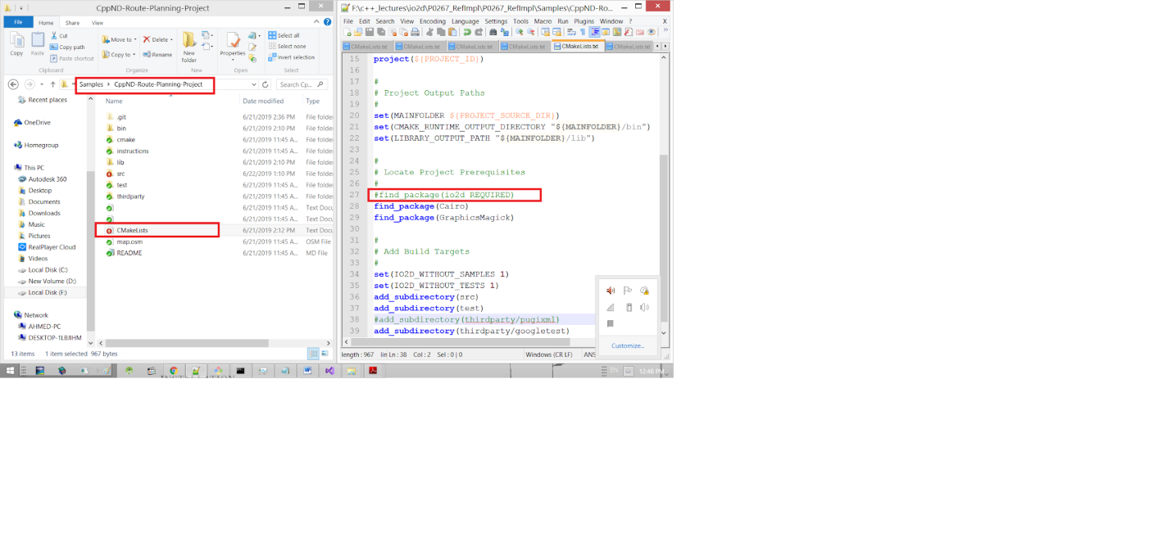

17- Open Cmake GUI

18- Past the directory for P0267_RefImpl repository in source code field like in the image below

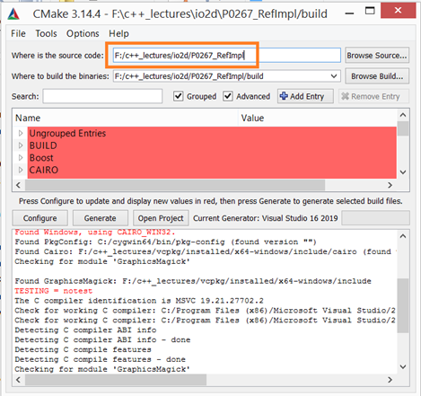

19- copy and past the same directory field below it + adding /build this will create folder where the files will be created

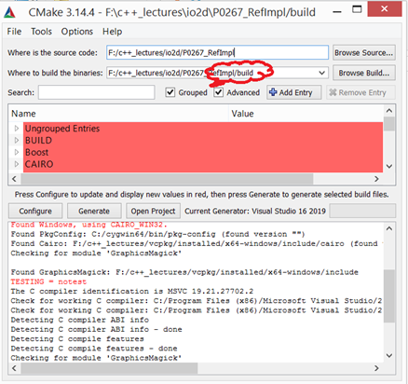

20- Click on Configure then specify the generator for this project Visual Studio 16 2019 and select specify toolchain file for cross-compliling then click Next

21-Brows vcpkg.cmake file, you will find this file in this directory .../vcpkg/scripts/buildsystems/vcpkg.cmake then click Finish

22- Wait until Cmake configure your project Then click on Generate

23- click on Open Project and wait until Visual Studio open your project

24- Write click on All_build and choose Build

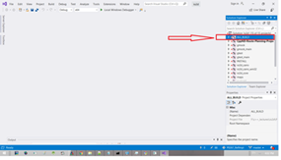

25- Navigate Git Bash to Debug folder under this directory .......\P0267_RefImpl\P0267_RefImpl\Samples\CppND-Route-Planning-Project\bin\Debugto Run your project using this command line

./CppND-Route-Planning-Project -f path to map.osm file This path should be like that, based on where you stored P0267_RefImpl repository F:/c++_lectures/io2d/P0267_RefImpl/P0267_RefImpl/Samples/CppND-Route-Planning-Project/map.osm

So congratulations, After doing that your code should be run and see that as output

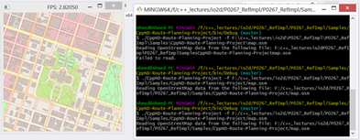

To get Access to your project files click on source_files like in image below

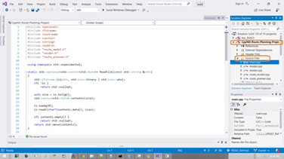

Hope this could help you. Have a nice day